Angela Parr’s Wildlife Art Class!
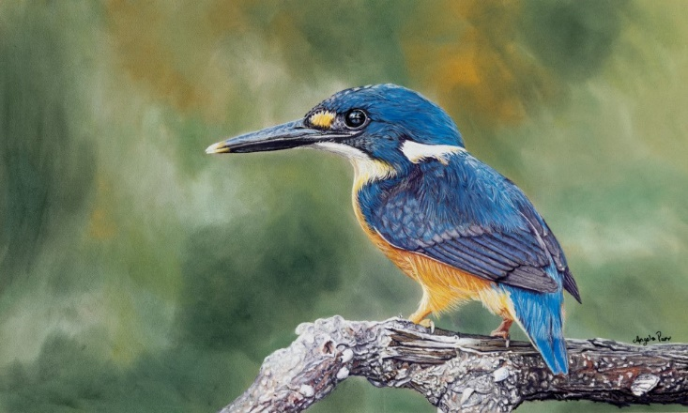

SUBJECT MATTER: Wildlife - birds and other animals.
Learn how to achieve all those tricky bits - eyes, feathers and fur, creating interesting compositions which also depict the structural accuracy and character of the creature you are painting.
We may not get to complete an artwork, but we will definitely learn how to do so.
I will provide the reference material. If you wish to bring your own images of animals and birds feel free to do so, HOWEVER they must not be subject to copyright.
I work in PASTELS – Pan Pastels, Sticks and Pencils and will be demonstrating in these. Obviously, I will teach towards this medium, however if this is not your preferred medium then bring what you normally use and I’m sure you will still get some benefit from the class.
- Pastels – sticks/ pans/ pencils - whatever brands you have. (NOT Oil Pastels though.)
- An old towel
- Glassine paper – one sheet and an offcut to rest your hand on
- Pastel paper – I prefer Clairefontaine Pastelmat Board, plus a scrap piece
- Artist quality tracing paper
- Paper towel and/or clean rags
- Stanley knife/ sharpener and a container for the shavings
- Clean white glove with thumb and forefinger cut out
- Paper stumps, blenders, sponges, cotton buds (preferably those with wooden stems), wooden skewer.
- Desk easel if desired, or portable standing easel.
MUST HAVES
- HB, 2B pencils
- Red pen or pencil
- Soft Rubber and Kneaded Rubber
- Cartridge Paper – A4 minimum size, either in a pad, book or loose pages
- A board to tape your work onto (must be larger than your paper).
- Masking Tape or bull clips
- Ruler
- Wet wipes
- Small notebook if you are a note taker

